Prava, membership, permissions, securable

# Popis, navod

**Prava se pro stoupu nastavuji v Admin TestCZ , rovnou je nastavit v Admin Production verzi aby po vikendu nezmizely**

O pravech zatim nevim skoro nic. V databazi jsou to tabulky Membership.

Ve spravovadle jsou jednotlive zalozky pod ruznymi pravy a to je definovane v xamlu takto :

xmlns:membershipPermissions="clr-namespace:MIR.Media.Framework.MembershipPermissions;assembly=MIR.Media.Framework"

<Grid membershipPermissions:Permission.DisabledVisibility="Collapsed"

membershipPermissions:Permission.NeededPermission="{membershipPermissions:Permission SecurableName={x:Static Membership:SecurableValues.MediaTypeAdministration}, PermissionName={x:Static Membership:PermissionValues.Visible}}">

<Grid.RowDefinitions>

<RowDefinition Height="*" />

<RowDefinition Height="Auto" />

</Grid.RowDefinitions>

<telerik:RadGridView

membershipPermissions:Permission.DisabledVisibility="Visible"

membershipPermissions:Permission.NeededPermission="{membershipPermissions:Permission SecurableName={x:Static Membership:SecurableValues.MediaTypeAdministration},

PermissionName={x:Static Membership:PermissionValues.Manage}}"

AutoGenerateColumns="False"

Kliknutim na CTRL + MediaTypeAdministration se dostanu do tridy SecurableValues ve spravovadle:

namespace MIR.Media.Admin.Membership

{

public class SecurableValues

{

public const string CreativeAdministration = "CreativeAdministrationViewModel";

public const string TvLogAdministration = "TvLogAdministrationViewModel";

public const string MediaManagement = "PressMediaManagementViewModel";

public const string MediumDetailAdministration = "MediumDetailAdministrationViewModel";

public const string SplitRegionAdministration = "SplitRegionAdministrationViewModel";

public const string MediaPricingAdministration = "MediaPricingAdministrationViewModel";

public const string MediaMatchingDefinition = "MediaMatchingDefinitionViewModel";

public const string PressSuitableFractionsAdministration = "PressSuitableFractionsAdministrationViewModel";

public const string MediaTypeAdministration = "MediaTypeAdministrationViewModel";

public const string PmFloodgate = "PmFloodgateViewModel";

public const string MembershipManager = "MembershipManagerViewModel";

public const string AresUpdater = "AresUpdaterViewModel";

public const string AssignUsers = "AssignUsers";

public const string SlicedChannelsAdministration = "SlicedChannelsAdministration";

public const string GaietyDetector = "GaietyDetectorViewModel";

public const string MessagesCopying = "MessageCopyingViewModel";

public const string SelfPromotionDefinition = "SelfPromotionDefinitionAdministrationViewModel";

public const string PublisherAdministration = "PublisherAdministration";

public const string SdaImport = "SdaImportViewModel";

public const string MessageRepricing = "MessageRepricingViewModel";

public const string RadioException = "RadioExceptionViewModel";

public const string SponsoredProgrammeAdministration = "SponsoredProgrammeAdministrationViewModel";

public const string BroadCastingTimeZonesAdministration = "BroadCastingTimeZonesAdministrationViewModel";

public const string TranslationAdministrationViewModel = "TranslationAdministrationViewModel";

public const string TranslationEdit = "TranslationEdit";

public const string MediaPriceLimitsAdministration = "MediaPriceLimitsAdministration";

public const string EnvironmentAdministration = "EnvironmentAdministration";

public const string AuditStampAdministration = "AuditStampAdministration";

public const string VmAdministration = "VmAdministration";

public const string VmChannelGroupsMatching = "VmChannelGroupsMatching";

}

}

Dalsim kliknutim na nazev property se dostanu do ScreenInstalleru kde jsou registrace jednotlivych screenu do Castlu a tady se rika :

public static void RegisterMediaTypeAdministrationTabSheetClass(IWindsorContainer container)

{

container.Register(

Component.For<MediaTypeAdministrationViewModel>().ImplementedBy<MediaTypeAdministrationViewModel>().Named("mediaTypeAdministrationViewModelClass")

.DependsOn(

Property.ForKey("IconImageSourcePath").Eq("pack://application:,,,/MIR.Media.Admin;component/Icons/MediaType.ico"),

Property.ForKey("ImageWidth").Eq(m_properties.CommonIconImageWidth),

Property.ForKey("SecurablePermission").Eq(new SecurableIdPermissionIdWrapper(SecurableValues.MediaTypeAdministration, PermissionValues.Visible))

).LifestyleSingleton());

}

Rika se tu, ze trida ma zavislost na properte SecurablePermission poskytnute tridou SecurableIdPermissionIdWrapper. V konstruktoru MediaTypeAdministrationViewModel, zadna takova zavislost neni. Jedna se tedy o zavislost ~~ve view asi..~~ Bude to nekde na bazovce

Prejdu teda do tridy SecurableIdPermissionIdWrapper

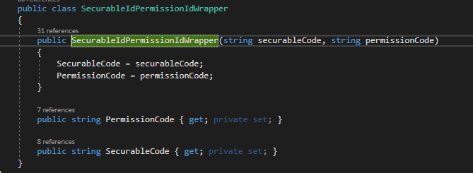

Tato trida dostane jako securableCode = "MediaTypeAdministrationViewModel”

a jako permissionCode = "Visible"

Trida PermissionValues:

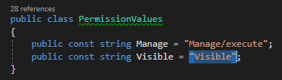

Tolik co se tyce visibility ruznych view podle nastaveni.

**Button a jeho obsluha**

Ve spravovadle jsou zalozky ve kterych se obsluha tlacitek provadi tim ze jednotlive zalozky jsou v conductoru. Muze za to Caliburn. Nejsou tu teda commandy .

Zamezeni obsluhy tlacitka na zaklade prav je provedeno takto Stejne view a namespace jako nahore:

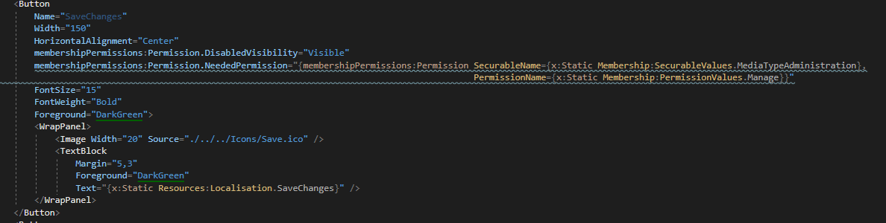

Trida od ktere dedi zalozky je ScreenWithIcon : Screen, IHasIcon, IhaveMembershipPermission.

A ma propertu public SecurableIdPermissionIdWrapper SecurablePermission { get; set; }

**Problem:**

Prni pokus v cenikovadle selhal protoze mi neslo nareferencovat MIR.Media.Framework. Ani kdyz jsem nainstaloval balicky Framework.Membership.Gui, Core, Common

xmlns:MembershipPermissions="clr-namespace:MIR.Media.Framework.MembershipPermissions;assembly=MIR.Media.Framework"

**Reseni:**

[‎4/‎23/‎2018 10:01 AM] Peter Hlavenka:

Ahoj, upravuju cenikovadlo. Pokousim se dostat checkbox omezujici datum pod prava.  Ve spravovadle je namespace : xmlns:MembershipPermissions="clr-namespace:MIR.Media.Framework.MembershipPermissions;assembly=MIR.Media.Framework"   a prava na tlacitka jsou nastaveny takto:  MembershipPermissions:Permission.NeededPermission="{MembershipPermissions:Permission SecurableName={x:Static Membership:SecurableValues.MediaTypeAdministration},

                                                                                                                PermissionName={x:Static Membership:PermissionValues.Manage}}"           Nainstaloval jsem balicky Framework.Membership.Core, Common a Gui, ale cenikovadlo porad do Frameworku nevidi . Nevis proc ?

[‎4/‎23/‎2018 10:02 AM] Petr Holubec:

cau, co znamena nevidi?

[‎4/‎23/‎2018 10:03 AM] Peter Hlavenka:

Namespace je cervene a neda se definovat zadna properta ktera je v tomto prostoru

[‎4/‎23/‎2018 10:03 AM] Petr Holubec:

assembly MIR.Media.Framework mas nareferencovanou?

[‎4/‎23/‎2018 10:04 AM] Peter Hlavenka:

samotnou assembly ne jen jeji casti jako validation atd

zkusim

[‎4/‎23/‎2018 10:11 AM] Peter Hlavenka:

Tak mam referencovane jen Mediaresearch.Framework . Jak pridam referenci na MIR.Media.Framework ? To mam pridat do projektu celou assembly ?

[‎4/‎23/‎2018 10:12 AM] Petr Holubec:

ano

[‎4/‎23/‎2018 10:12 AM] Peter Hlavenka:

diky

( pridame csProj : Solution -> add => existingProject => naklikam do MIR.Media …. Az najdu csProj. A ten pridam.)

# SimLog:

SimLog uz je zaveden\ v tabulkach membership, ale jen pro BG.

SELECT * FROM [MediaData3BGAuto].[Membership].[Application]



SELECT * FROM Membership.Securable s WHERE s.Description LIKE 'SimLog%'

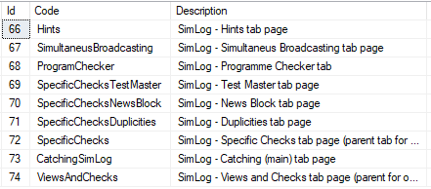

SELECT * FROM Membership.SecurableToPermission stp WHERE stp.SecurableId > 65 AND stp.SecurableId <75

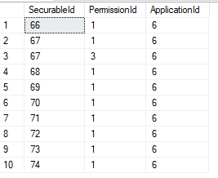

SELECT * FROM Membership.Permission p

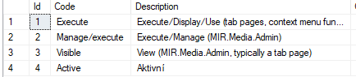

Pokud tedy mam dat tlacitka a contextMenu v SimLogu na zalozce SimultaneousBroadcastingTabPage pod specialni prava, musim si vytvorit nove securable, nastavit securableToPermission, kde priradim permission manage nebo execute a upravim xaml. Do registrace budu muset pridat zavislost na nove securable.

# Cenikovadlo:

Script kterym jsem pridal Securable a ostatni zaznamy do tabulek MemberShip:

c:\Users\phlavenka\OneDrive\Nielsen prace\Moje poznamky Nielsen\My Scripts\Pricing\Vytvoreni Membership.Securable pro checkbox v Pricingu ktery omezuje vybrany datum v datepickeru podle nastaveni v configu..sql

1. Pridame teda csProj MIR.Media.Framework
2. V xamlu si pridame namespace a omezeni k checkboxu:

<UserControl

xmlns:Membership="clr-namespace:MIR.Pricing.Membership"

xmlns:MembershipPermissions="clr-namespace:MIR.Media.Framework.MembershipPermissions;assembly=MIR.Media.Framework"

d:DataContext="{d:DesignInstance local:TvIntervalProviderViewModel}">

<StackPanel Orientation="Horizontal" Visibility="{Binding Path=Visibility}">

<TextBlock VerticalAlignment="Center" Text="{x:Static localisation:Localisation.DateRestriction}" />

<CheckBox

Margin="5,0,20,0"

VerticalAlignment="Center"

MembershipPermissions:Permission.NeededPermission="{MembershipPermissions:Permission SecurableName={x:Static Membership:SecurableValues.TvIntervalProvider},

PermissionName={x:Static Membership:PermissionValues.Manage}}"

IsChecked="{Binding IsRestrictered, Mode=TwoWay, UpdateSourceTrigger=PropertyChanged}"

ToolTip="{x:Static localisation:Localisation.DateRestrictionToolTip}" />

</StackPanel>

</UserControl>

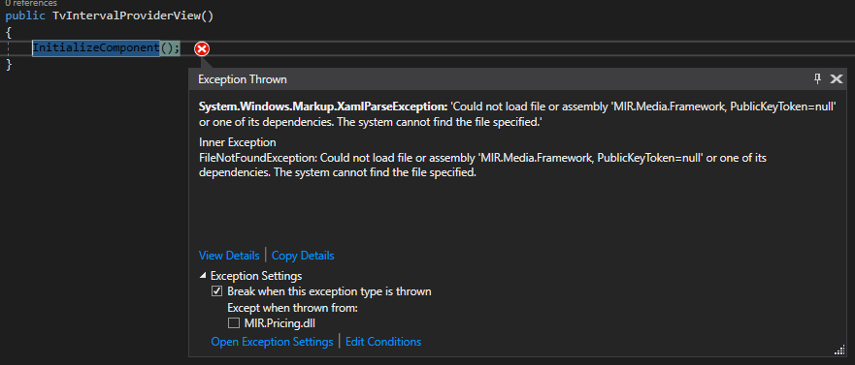

1. Je tam nejaka dependency kterou musim pridat do castlu

public static void RegisterMediaTypeAdministrationTabSheetClass(IWindsorContainer container)

{

container.Register(

Component.For<MediaTypeAdministrationViewModel>().ImplementedBy<MediaTypeAdministrationViewModel>().Named("mediaTypeAdministrationViewModelClass")

.DependsOn(

Property.ForKey("IconImageSourcePath").Eq("pack://application:,,,/MIR.Media.Admin;component/Icons/MediaType.ico"),

Property.ForKey("ImageWidth").Eq(m_properties.CommonIconImageWidth),

Property.ForKey("SecurablePermission").Eq(new SecurableIdPermissionIdWrapper(SecurableValues.MediaTypeAdministration, PermissionValues.Visible))

).LifestyleSingleton());

}

Rekneme teda castlu, ze nas viewModel ma zavislost . Jenomze tento ViewModel se nikde neregistruje, je vytvoreny z xml .

MessagePricingInstaller:

container.Register(Component.For<TvIntervalProviderViewModel>().ImplementedBy<TvIntervalProviderViewModel>()

.DependsOn(Property.ForKey("SecurablePermission").Eq(new SecurableIdPermissionIdWrapper(SecurableValues.TvIntervalProvider, PermissionValues.Visible))));

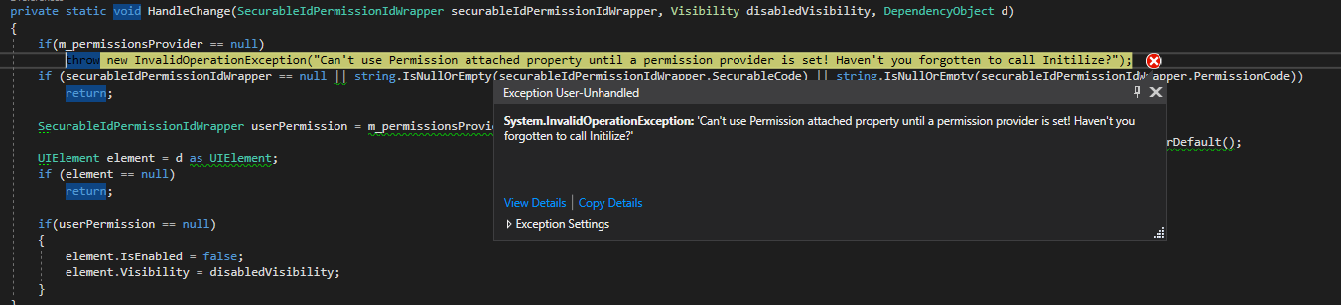

1. Musi se teda zavolat metoda Initialize na tride MIR.Media.Framework.MembershipPermissions.Permission

Ve spravovadle se tak deje uz v ShellViewModelu v metode SetPermissions():

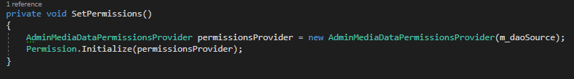

Vytvorim si v cenikovadle tridu jako je AdminiMediaDataPermissionProvider ale tady se bude jmenovat PricingMediaDataPermissionProvider

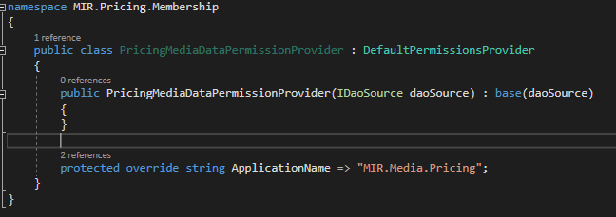

1. Kdyz mam tridu vytvorenou muzu zavolat ShellViewModel.SetPermissions(); Ta se vola v konstruktoru ShellViewModelu.

using Permission = MIR.Media.Framework.MembershipPermissions.Permission;

1. Mame zakazano :

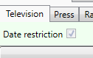

1. Kliknutim na view se stalo toto :

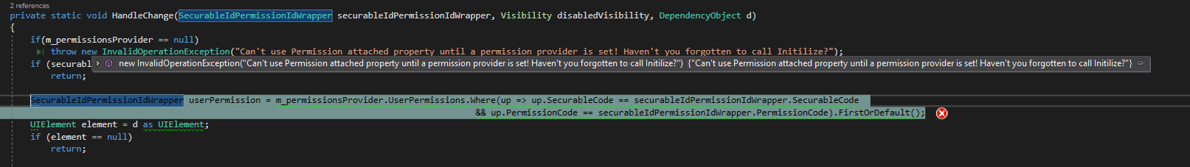

1. Zatim to chapu tak, ze aplikace by teoreticky mohla byt v poradku, jen pricing nema nastavene ve spravovadle zadne Securable coz je UIElement a nema vyplnene zaznamy v tabulkach MemberShip v databazi.

Nastavil jsem novou aplikaci ve Spravovadle :

applicationId = 10

securable = 265 TvIntervalProviderViewModel

userId = 160

Pada to ve tride MIR.Media.Framework.MembershipPermissions.Permission protoze UserPermissions = null

Zakomentovane radky v TvIntervalProviderView

Nedalo mi to a porazil jsem to .   Chyba byla v takove prkotine:   protected override string ApplicationName => "MIR.Media.Pricing";       melo byt jen MIR.Pricing ..

takovyho casu..

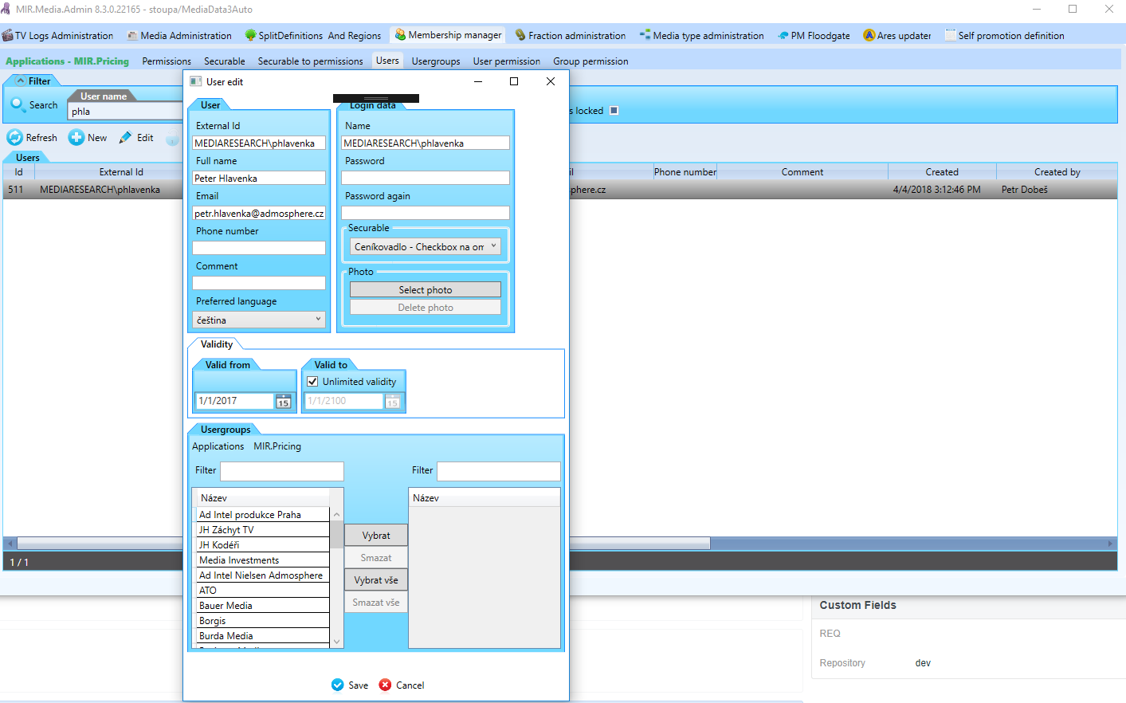

Je potreba mit vybranou aplikaci

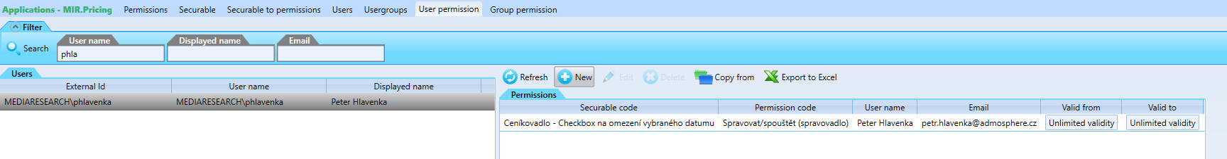

Zalozky musi byt pod pravy vsechny takze zmenime nazev TvInterval na :

public const string IntervalProvider = "IntervalProviderViewModel";

a

MembershipPermissions:Permission.NeededPermission="{MembershipPermissions:Permission SecurableName={x:Static Membership:SecurableValues.IntervalProvider},

PermissionName={x:Static Membership:PermissionValues.Manage}}"

A jeste:

container.Register(Component.For<TvIntervalProviderViewModel>().ImplementedBy<TvIntervalProviderViewModel>()

.DependsOn(Property.ForKey("SecurablePermission").Eq(new SecurableIdPermissionIdWrapper(SecurableValues.IntervalProvider, PermissionValues.Visible))));

A ve spravovadle taky :

Prejmenovano

**Problem:**

Kdyz user nema prava pri prekliknuti zalozky aplikace pada protoze UserPermissions == null a source nemuze byt null.

**Reseni:**

DefaultPermissionProvider od ktereho dedi PricingPermissionProvider vraci z daa metodou GetApplication null . Jednoducha vec Pricing jeste neni v tabulce Membership.Application . Reseni pustit script ktery zalozi prava